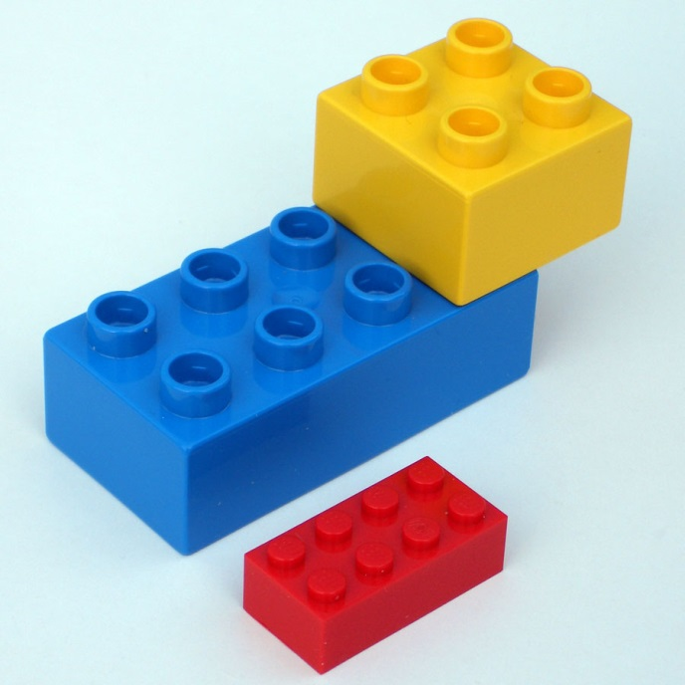
Wisconsin Directors of Religious Education Federation (WDREF) Preconvention

Building A Relationship With Christ

“Lego” of your distractions and spend some time connecting with other religious educators and gathering fresh ideas to enhance your ministry. The Diocesan Association of Religious Educators (DARE) from the Diocese of
La Crosse invites faith formation leaders and catechists to attend this WDREF preconvention.

DATE: Sunday, November 4, 2018
TIME: 4:00-6:30 pm Free supper and presentation
Location: St. Joseph Parish
1709 Wyatt Ave., Stevens Point, WI 54481
Keynote: Jared Dees – From Education Towards Encounter

Pope St. John Paul II wrote, “The definitive aim of catechesis is to put people not only in touch with, but in communion with Jesus Christ.” Jared will offer practical methods and strategies that will lead you and the young people you minister to, into an encounter with Christ.

- - - - - - - - - - - - - - - - - - - - - - - - - - - - - - - - - - - - - - - - - - - - - - - -
To register: If you are attending the WDREF convention (Nov. 5-6), you may sign up on the convention registration form. All others please call, e-mail or mail the following info to
Lynn Meyer at the address above. Phone: 715-341-1617 x114 lmeyer@stjoespoint.org

Name: ____________________________________________________________

Parish/School: ______________________________________________________

Address: ___________________________________________________________

Phone: _________________________ Email: _____________________________

