Registration

Registration fees include private rooms with shared bathrooms, meals, and social. To help with planning, please indicate if you are coming for the pre-retreat evening, and if you will be present for breakfast on Monday.

Please make checks payable to WDREF and register by September 30, 2017 to receive the Early Bird Special.
All registrations need to be in no later than October 15, 2017.

If you have any questions please contact Adele Svetnicka at 715-479-8704 or adele@stpeterseagleriver.org.

Massage is available through St. Anthony Spirituality Center during the retreat. As people of the incarnation, we believe that the body is sacred and should be treated with tenderness. Call 715-443-2236 for

The Early Bird Catches the Worm!
If you register by September 30, WDREF members pay $110.00 and Non-Members pay $135.00.
Price increases on October 1.

Retreat Schedule
Sunday, October 29
(Pre-Retreat – Optional)
6:00 - 7:00 PM Early Registration
7:15 – 7:45 PM Evening Prayer
7:50 - 9:00 PM Social

Monday, October 30
8:00 AM Breakfast
9:00 AM Registration
9:30 AM Welcome,
Opening Prayer
& Presentation

10:45 AM Break
11:00 AM Adoration
11:30 AM Mass
12 Noon Lunch
2:30 PM Presentation
3:30 PM Free Time
4:00 PM Reconciliation
5:00 PM Evening Prayer
5:30 PM Dinner
7:00 PM Presentation
8:30 PM Social time

Tuesday, October 31

8:00 AM Breakfast
10:00 AM Presentation
11:00 AM Adoration
11:30 AM Mass & Farewell

WDREF Fall Retreat
Deepening our Communion with God

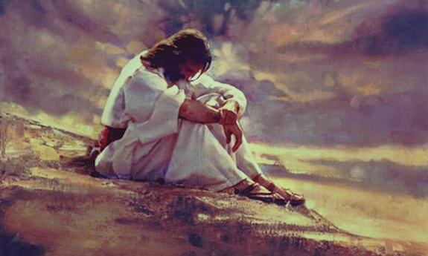

St Anthony Spirituality Center
Marathon, WI

Monday and Tuesday
October 30-31, 2017

Sponsored by WDREF
(Wisconsin Directors of Religious Education Federation)

Deepening Our
Communion with God

Those who serve the Church often find it difficult to cultivate the deepening of communion with God. Looking to Jesus and finding that personal space away from demands and distractions is essential for healthy, grounded service and ministry. Using examples from the Gospels and practical suggestions, Sr. Jolynn helps us create a personal sanctuary for prayer. Deeper communion with God can be a reality for all of us!

“…but [Jesus] would withdraw to deserted places and pray.”
Luke 5:16

“ Jesus withdrew toward the sea with his disciples.” Mark 3:7

“He said to them, ‘Come away by yourselves to a deserted place and rest a while.’ People were coming and going in great numbers, and they had no opportunity even to eat.” Mark 6: 31

About our Facilitator
Sr. Jolynn Brehm, FSPA, is a Franciscan Sister of Perpetual Adoration. She has been a retreat director and spiritual director since 1989 and began offering preached retreats in 2005 at retreat centers and for communities of Sisters throughout the Midwest. She joined St. Anthony Spirituality Center as spiritual leader in July 2015.
Please make checks payable to WDREF.
Return registration form and payment by
(Early Bird) September 30, 2017
(Regular Bird) October 15, 2017 to
WDREF Retreat, c/o Adele Svetnicka
5001 County Road G
Eagle River, WI 54521

Registration Form - WDREF 2017 Fall Retreat

Name ______________________________________ Special/Diet Needs _____________________________

Address __________________________________________________________________________________

Email _______________________________________________ Parish _______________________________

Phone (home/work/cell) __________________________________________________________ Gender M/F

Member of: MDREO _____ SUMMIT _____ ProCLAYM _____ DARE _____ MAREDA _____

Check all that apply:
___ Sunday, Pre-Retreat evening and overnight $50.00

___ Yes ___ No I will be present for Monday breakfast $8.00

___ Monday–Tuesday, Early Bird member $110.00;
Regular Bird member $135.00

___ Monday–Tuesday, Early Bird non-member $135.00;
Regular Bird non-member $160.00

$______ Total Due

Her background also includes elementary and secondary educator, pastoral associate, co-founder and director of Marywood Spirituality Center in Arbor Vitae.
Her special interests include delving into Scripture, all things Franciscan, and exploring the connections of nature and creation with our lives.

